   | Raghu Vansh Mani Mishra
  Mobile No. | (+91) 8948082735
  Experience | Fresher
  Email Id | raghuvansh2735@gmail.com
  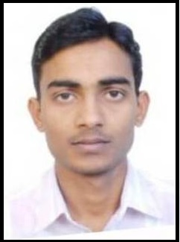

Objective

- To begin mycarrier in a well reputed company where I can contribute my knowledge and learn more challenging tasksday to day
Professional Qualification

Certification: -
- Course on computer concepts (CCC)
Training: -
- National Skill Qualification Framework Level 3

Computer Knowledge
- Microsoft words
- Excel
- PowerPoint

Academic Records
Education | Board / University | Year | Percentage
10th | State Board (UP Board) | 2012 | 82.0
12th | State Board (UP Board) | 2014 | 74.8
B. Sc Maths | Dr. Ram Manohar Lohiya Awadh University, Faizzabad | 2017 | 56.0
D.El.Ed | Janhit Institute of Education & Information, Grater Noida | 2017-2019 | Pursuing

Strength

- Good Communication Skill
- Good Team player
- Quick learner
- Self motivated

Personal Detail

Father’s Name | Sri Mahipal Mishra
Mother’s Name | Smt. Geeta Devi
Date Of Birth | 20-05-1997
Language | Hindi, English
Permanent Address | Village Amrai, Post-Lakkarampur, P.S.Visheshwarhanj, Dist. Bahraich-271821
Current Address | Sri Shiv Kutiya Mandir, Hari Nagar Ashram, New Delhi

Declaration
I hereby declare that all the details given above are true to the best of my Knowledge.
Place: New Delhi Raghu Vansh Mani Mishra

