RESUME
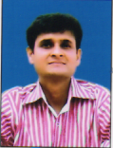
SANJAY KUMAR
Sanjay Gandhi Nagar Road No. – 10
Hanuman Nagar, Patna – 800026
Cell # 9471018606
Sanjaykumar.dbsd@gmail.com

PERSONAL DATA
Father’s Name : Late Dr. Jitram Pathak
Date of Birth : 8 March 1969
Sex : Male
Marital Status : Married
Language : Hindi, English

SKILLS AND INTEREST
* Good knowledge of computer.
* Good in oral and written communication.
* Good knowledge of official and paper work.
EDUCATIONAL QUALIFICATION
* M.A. in Psychology
* M.A. in History
* Ph.D. in Psychology (Thesis Submitted)

EXPERIENCE
* Worked in Drishti Coaching Institute, Ara from March. 2004 to
Dec. 2006 as a History and GS teacher.
* Worked in Success Centre, Patna from Dec. 2004 to Jan. 2007 as a
History and GS teacher
* Worked in Utkash Academy, Patna as a History and GS teacher
From Mar 2007 to Jan 2008.
* Know teach students at home.
Post Applied for
* General Awareness Teacher

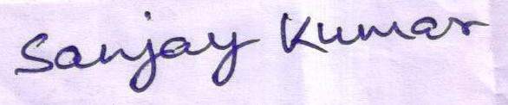
Signature

