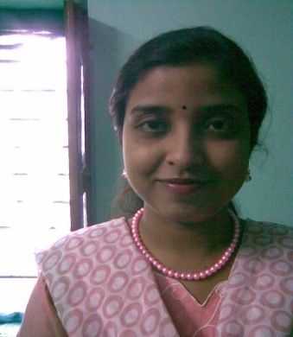
NAME –Tanaya Seth
Primary No.9836148411

E-Mail Address:tan_seth@rediffmail.com

Career Objective:

I would like to reach on the boom point of CARRIER by learning and implementing my knowledge and potentiality and facing challenges in every phase of life with ROBUST OPTIMISM and to be recognized as a Good Human Being.I start career in teaching for faculty position in institute ofCompetitive exam.

Educational & Technical Qualifications:
Name of Examination | Institute |  | Affiliate | Year of passing | Percentage Obtained
10 | Surendranath Girls’ High School |  | W.B.C.S.E | 2004 | 80
10+2 |  | Shibpur Hindu Girls’ High School | W.B.C.H.S.E | 2007 | 60
B.Tech |  | College of Engineering & management,kolaghat | W.B.U.T | 2011 | 70

Technical Skills: Diploma
Skill Category | Skill Name | Institute | Year of passing | Proficiency
Software application | COMPUTER BASIC,MS-OFFICE,C,C++,HTML | WEBEL | 2009 | COMPUTER BASIC,MS-OFFICE,C,C++,HTML,JAVA SCRIPT
DTP | PAGEMAKER,COREL DRAW,PHOTOSHOP | WEBEL | 2009 | PAGEMAKER,COREL DRAW,PHOTOSHOP
CORE JAVA Summer training | CORE JAVA | CMC ACADEMY | 2010 | CORE JAVA
In addition to,I’m presently learning advance java & j2ee from CMC ACADEMY.
Project Summary :
Project Name:Development and analysis of Fuzzy ADELINE for Gray image recognition and Image compression by PCA.
Tools & Platform:MATLAB (in frontend)and Oracle 9i(in backend)
Project Summary:
Here we recognized some image which stored in database table.We studies ADELINE,PCA,NEWRAL NETWORK which helped us to develop our project.We retrieve image of any person or object may be snapshot of any criminal activities using FUZZY LOGIC.We compressed image by PCA(Principal component and analysis) and windrow-off proposed model.

Personal Details:

Father’s Name-Shyamal kumar Seth.
Postal Address:45/2/1 Nabanaritala 1st Byelane Baksara-Howrah.
P.O:Baksara
District:Howrah
Pin code no:711 110

Permanent Address: 45/2/1 Nabanaritala 1st Byelane Baksara-Howrah.
P.O:Baksara
District:Howrah
Pin code no:711 110
Language Known:English,Bengali
Hobby:Listening songs,reading story books,net surfing
Extracurricular activity:I secured grade B in ENGLISH COMPETENCE TEST in class viii and secured grade B+ in class ix under ALL BENGAL MASS EDUCATION AND DEVELOPMENT ASSOCIATION.I also secured grade B in ACADEMIC SCIENCE CULTURE & PROMOTION SOCIETY(MEDHA SANDHAN PARIKSHA).

WORK EXPERIENCE:I have worked in CMC LTD AS A IT ENGINEER after that I worked in GSCE as a GI faculty.

Declaration:
I do hereby declare that all the above furnished information is true to the best of my knowledge. I carry the responsibility for the correctness of above mentioned particulars.I also declare my willing to work anywhere in India.

Tanaya Seth Applicant’s Signature

Place:Baksara-Howrah

