CURRICULUM VITAE

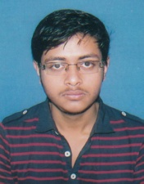
RISHAV BANERJEE

At-66/9A Sarat Ghosh Garden Road,
Dhakuria,
Kolkata-700031
Phone-9674789970
Email-rishavbanerjee10.rb@gmail.com
Dob-18/11/1994

Career Objective

To work on a challenging job profile which provides an opportunity to enhance my technical skills and knowledge, this could provide me an insight into new aspects so that it would be helpful for my career.

Education

- Bachelors of science from University of Calcutta, Vijaygarh Jyotish Ray College, Kolkata, 2012-2016.(PERCENTAGE- 51%)

- Completed 12th (WBHSE) in 2010-2012 Jagadbandhu Institution, Kolkata. (PERCENTAGE-73.2%)

- Completed 10th (WBSE) in 2010 from Jagadbandhu Institution, Kolkata. (PERCENTAGE-67.5%)

Technical Profile

- Language : C, C++, Net Technology

- Operating : Windows/Windows7/Windows8.1

- Application package : Ms Office

Strengths

- Work with positive attitude to contribute the healthy functioning of the organization.
- Self-confident and great patience.
- Analyzing every angle of the project before working on it.
- Willingness to learn.
- Adaptability to change environment.

