Curriculum Vitae

Name: SAMIM AHASAN Contact No: 9051827140
Date of Birth: 26.11.1987 Email Id: samim.vms@gmail.com
Gender: MALE
Father’s Name: MINHAJUDDIN SHAIKH
Address: CHANDI, BISHNUPUR, SOUTH 24 PARGANAS, 743503
Objectives:
- To serve your institution to the best of my ability and teaching experience.
- To fulfill the dreams and aspirations of the students.
- To keep intact the reputation and success rate of the institution.

Strength: I always try to explain students with real life examples in the simplest way.

Work Experience:
Apart from other experiences I have relevant teaching experience of General Intelligence/Reasoning in RICE Education for two years. Presently I am teaching in different non-branded institutes as a faculty of Reasoning for last two years.
Educational Qualifications:
Passed Madhyamik from WBBSE.
Passed H.S. from WBCHSC
And completed my Graduation from University of Calcutta

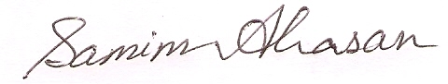
Date: 4th April, 2019 Signature

