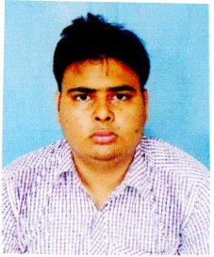
NAME : SUDIP KUMAR GHOSH
FATHER’S NAME : RABINDRANATH GHOSH
D.O.B. : 30/07/1997
ADDRESS : VILL. – RAGHUNATHPUR,P.O. –BARDA
PS.- UDAYNARAYANPUR, DIST. HOWRAH,
PIN CODE. -711401.
EMAIL ID . : gsudip327@gmail.com
MOBILE NO. : 9083180609
EDUCATION
QUALIFICATION :
EXAMINATION | NAME OF THE BOARD/UNIVERSITY | YEAR OF PASSING | MARKS OBTAINED(%) | DIVISION/GRADE
SECONDARY | W.B.B.S.E. | 2013 | 46.14 | B+
HIGHER SECONDARY | W.B.C.H.S.E. | 2015 | 76 | A
B.COM(GENERAL) | UNIVERSITY OF CALCUTTA | 2018 | 43.92 | P

LANGUAGE KNOWN : ENGLISH,BENGALI
OTHER QUALIFICATION : PASSED DIPLOMA IN FINANCIAL ACCOUNTING FROM YOUTH
COMPUTER TRAINING CENTER.
DECLARATION : I DECLARED THAT ALL THE ABOVE INFORMATION ARE TRUE,
TO THE BEST OF MY KNOWLEDGE AND BELIF.

