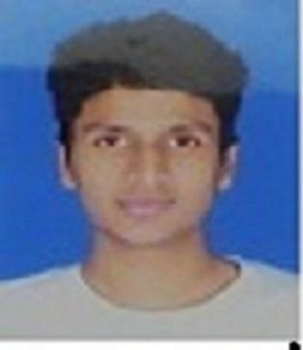

SUMIT GARG
smithgargvin@gmail.com; +91 9996931498

Professional Objectives:

Seeking a suitable and rewarding career in teaching, with an esteemed Organization, that would offer good advancement potential, challenges and opportunities to zoom my career growth, contributing to the success of the Organization.
Also, want to share my experiences as a civil services aspirant to the students in order to make their journey fruitful.

ACADEMIC QUALIFICATION:

BACHELOR OF TECHNOLOGY (Mechanical Engineering) 2011-2015
JMIT, KURUKSHETRA UNIVERSITY, INDIA Aggregate :63%

CLASS 12TH 2009-2010
DELHI PUBLIC SCHOOL, MARUTI KUNJ, GURUGRAM Aggregate :73%

CLASS 10TH 2007-08
HINDU SR SEC SCHOOL, NUH,HARYANA Aggregate :92%

EXPERIENCE IN UPSC AND STATE PCS EXAMS

Prepared for UPSC from 2015

Cleared Prelims of UPSC (2018 and 2019)

Experience of writing Mains of UPSC(2018 and 2019)

Cleared Prelims of HPSC (2021)

Experience of writing Mains of HPSC(2021)

Qualified Prelims- UKPSC (2021)
- Experience of Mains - UKPSC (2021)
- Qualified Prelims of HPSC (2022)
- Experience of writing Mains HPSC (2022)

Work Experience

- Intern at ADDA247 (Gurugram) - Content Developer (May, 2023 - Present) .

EXTRA CO- CURRICULAR ACTIVITIES

- Participated in an inter college essay competition
- Active volunteer at Indian Red Cross Society .
- Had been preparing for civil services .

SUMMARY OF SKILLS

- Ability to multi task and perform professional duties.
- Ability to manage time and prioritize tasks
- Professional in developing and maintain relationships with colleagues.
- Skilled in taking initiative and being proactive.
- Strong communication, academic research and interpersonal skills.

