SURBHI DAHIYA
7379920196
19925surbhidahiya@gmail.com
Objective: Developing content of UPSC/PSC based on my preparation since 4 years.

Education | Board | Year of passing | Institution | Percentage
PHD (Chemical Engg.) | IIT ROORKEE | PURSUING | IIT
M.TECH (Chemical Engg.) | HBTI(KANPUR) | 2017 | HBTI | 69%
B.TECH  (Chemical Engg.) | CSJMU(KANPUR) | 2015 | UIET | 75%
12TH(PCM) | PINEWOOD SCHOOL | 2010 | CBSE | 81%
10TH | SOPHIA GIRLS SCHOOL | 2008 | CBSE | 84.4%

UPSC- Attempt 3 times(failed)
Though prepared sincerely , but could not qualify.

Sample of my notes making.
Fly ash- Fly ash consists of Silicion oxide, calcium oxide.
Mars opposition Effect=
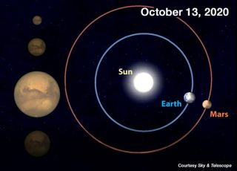

Electronic Vaccine Intelligence network= (Under National family mission) in partnership with UNDP.(Ministry of Family & Health welfare)
MOSAiC Mission-(For Arctic study)
ThatteKkad Bird Sanctuary= (Also called Salim Ali Bird Sanctuary) (Kerala)
SCO=(Shanghai Cooperation Organisation)=China, Kazakhstan, Krgyzstan, Russia, Tajikistan, Uzbekistan, (India and Pakistan(in Astana)in 2017). 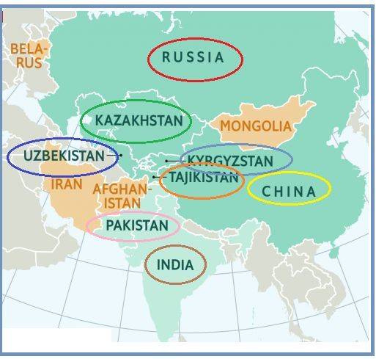
Electoral Bonds- (Promissory note)(free of interest)(does not contain the name of donor)
5 eyes(FVEY)- An intelligence alliance. India joined as the seventh member against the encrypted social media messages.
The Five eyes consist of Australia, Canada, New Zealand, UK, USA.(6th member is Japan)
BECA agreement- will allow India access to geospatial intelligence and will enhance accuracy of automated systems and weapons like drones.(Not yet signed)
COMCOSA and LEMOA (signed)
World Economic Outlook- by IMF
The MRP of neem-coated urea, for instance, is fixed by the government; The MRPs of non-urea fertilisers are decontrolled or fixed by the companies.
Shore –Temple (Mahabalipuram),
Brihadesvara temple- (Thanjavur)

