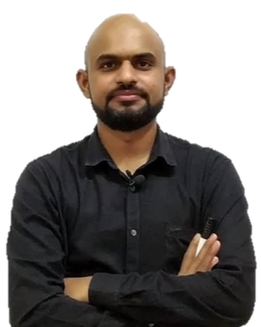

+91-8827565666
SANDEEP UPADHYAY  svitssandy23@yahoo.com

Career Objective

To become member of organization, where I can contribute my knowledge, analytical skills and progressive attitude towards consistent growth of the organization.

Academic profile

- B.E (Mechanical) (2010-14) from S.V.I.T.S. INDORE (RGPV) with Aggregate 7.38
- 12th from SARASWATI H.S.SCHOOL MORENA (MP BOARD) with 84.6%
- 10th from SARASWATI H.S.SCHOOL MORENA (MP BOARD) with 93.6 %

Achievements

- SSC CGL 2019 MARKS 552/600 (till tier 2) ( MATHS – 200/200)
- SSC CGL 2018 (PRE, MAINS & tier 3 ) qualified, Total score 574.88/700
- SSC CGL 2017 (all 4 tier) qualified final list out
- SSC CGL 2016 (all 4 tier) qualified final list out
- (SSC CPO, SBI & RRB PO, RRB NTPC) PRE qualified
- CAT Quant (99.9%) CMAT Quant (99.90%)
- GATE qualified (2014)

Professional Experience

- Sharda academy indore
- Designation – Maths faculty
- Experience period – 2019 to till date
- Mahendras educational Pvt Ltd
- Designation – Maths faculty
- Experience period – July 2017 to 2019
- CH Edgemaker Indore
- Designation - Assistant faculty of QA, DI & LR
- Experience period – July 2014 to September 2016
- Teaching experience of CMAT, PG-CET, UG-CET, Campus & Banking classes

Personal Traits

- Good Analytical skills and optimistic approach to problems.
- Quick grasping and adaptation to new environment.
- Good teamwork spirit.

Co-Curricular & Extra Curricular Activities
- Team member of SPECTRUM business fare of CH Edgemaker
- Participant of dance competition of CH cultural festival
- Core committee member of college annual festivals
- Volunteer in college annual festivals
- Team member of college kabaddi team

Interest

- Dancing , listening to music

Personal Details

Name: Sandeep upadhyay
Present Address: 301 yash regency phooti kothi indore
Date of Birth: 23 September 1992

Declaration

I hereby declare that the above-mentioned information is correct to the best of my knowledge and I bear the responsibility for the correctness of the above-mentioned particulars.

Date - 22-01-2020 Sandeep upadhyay
Place - Indore

