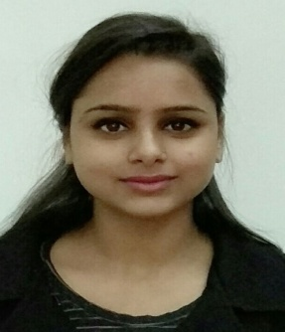
Sneh Lata
Contact No. 7696724007, 8847584773
Email id: sneh.sne26@gmail.com
Objective

To work in a globally competitive environment with a prestigious organization on challenging assignments that shall yield the twin benefits of the job satisfaction and a steady-paced professional growth.

Academics

Degree / certification | Board / University | Year of passing
Msc-IT | Punjabi university Patiala | 2014
Bca | Punjabi university Patiala | 2012
Higher Secondary school | PSEB | 2009
Lower Secondary school | PSEB | 2007

Extracurricular Activities

- Participated in athletics meet at different levels.
- Participated in the tech fest 2012, as host, held in Asra group of institution.
- Participated in various Quiz competitions at college level.
- HR SPOCS certificate for best HR performer.

IT Acquaintance
- MS-Word, MS-Excel, MS-PowerPoint

Experience
- WORKED IN EDUJOBS PVT. LTD. AS A SENIOR CAREER COUNSELOR FROM JULY 2017 To OCTOBER 2018

Job Responsibilities

- Dealing with the visitors & entertaining new enquiries for the admissions.
- Team Management- Handling marketing and junior counseling team.
- Student coordinator: Taking one to one counseling sessions of the students, resolving their issues regarding the organization.
- Trainers Coordination for smooth execution of the classes.
- Maintaining reports on daily basis.
- Handling various Government portals.
- E-mailing.
- MIS Preparation.
- Handling HR responsibilities which include documentation of new employees and assigning them their job responsibilities.
- Office management & handling all the administrative work which include managing petty cash, vendor management etc.

- WORKED AT AAA BRIGHT ACADEMY AS COUNSELLOR FROM AUGUST 2015 TO APRIL 2017

Job Responsibilities
- Attending the new visitors and providing them guidance for the particular course.
- Handling the queries of the students regarding their course.
- One to one interaction with the students.
- Keeping the record of the data for every course.
- Providing the students require information and assistance to navigate the institute system and to make appropriate decisions.
- Handling admin work.
Projects
- Worked with Pradhan Mantri kaushal kendra as senior career counselor.
Strength

- Hard Working, Positive attitude, learning capability and Self Confidence.
- Zeal to work with dedication & interest.
- Good communication skills and can easily interact with the people.

Hobbies

- Travelling, Camping, Tracking, cooking, Reading
- Internet Surfing

Attitude towards Life

To attain the best I can with a smile, positive attitude and approach towards my work and life.

Personal Information

Father's Name | Vishwanath Singh
Mother's Name | Shyama Devi
Permanent address | Shyamasadan, Green City, Dhuri
Nationality | Indian
Religion | Hindu
Date of birth | Jan 26th , 1992
Languages known | English, Hindi, Punjabi
Declaration:
I _______________declare that the above mentioned information is all true to the best of my Knowledge & experience & I would like to join the organization where I would be able to Learn new things & grow more in my career.

