Name: Subala Rani
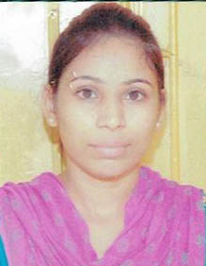
V.P.O. Ghugiana (faridkot)
Email: subalasingharia@gmail.com
MOBILE NO:9780485144
Personal profile: I am very very devoted to my work. I always try to learn something new and learn very fast. I have enough confidence to do any world and highest efficient.
Keys skill and qualities:-
1. Languages: c++,HTML,PHP
2. Operating system: Microsoft window.
3.data base:SQL
Career objectives
- To give in and contribute the skill and education that I have acquired into a challenging and taugh sales situation in order to achive the desired result.

EDUCATION AND TRANING:
1 .Marticulation:(2006) govt high school(ghugiana) board P.S.E.B
have scored 65%I
- 12th(2008)Govt girls sen sec school fdk
Medium qualification(2008 up to 2011)
I have scored 67%
- Malwa polytechnic college faridkot(Punjab)
Punjab technical university,jalandhar.
I have scored 72%
- Bachelor degree:may(2011-14)
Adesh insititiute of engg.technology university
I have scored 78%
TRAINING PROCESS: 6 weeks summer intership
Course c++
Project name:student management

: 6 months intership(dec-2013 may 2014)
Experience : 1 year computer teacher
School( s.m.sm.sen sec school jhotiwala)

PERSONAL DATA:
. NAME : Subala rani
D.O.B: 26 JAN.1988
GENDER: Female
Natonality:Indian
Languages: ENGLISH,HINDI,PUNJABI
………………………………………………………………..0000000000000000………………………………………………………………………………….

