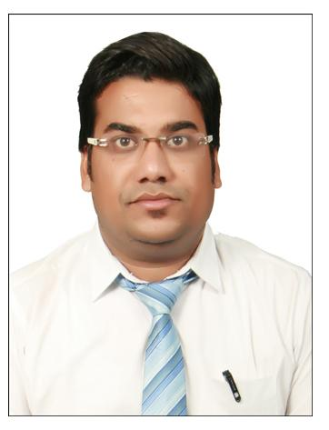
VARUN AGRAWAL
Scheme No.71
Opp. Arihant Hospital
Gumasta Nagar Indore (M.P.)
+918118853800
varun.agrawalsatna@gmail.com

CAREER OBJECTIVE
To give the best with my full capability, determination & optimism seeking a challenging career position where unique blend of my talents can be effectively utilized by a company offering long- term opportunities for professional growth to recognise my prior experience analytical skills & dedicated performance.

OVERVIEW

- Post Graduate in Management (PGM) with major in Finance and minor in Marketing.
- Well versed with MS OFFICE (EXCEL, WORD, and POWER POINT)
- 4+ years of Professional NBFC and educational experience.
WORK EXPERIENCE

Has been associated with Bhawti Academy in Indore as G.S. & Current Affairs Static Gk Faculty.
Have experience of CLAT, AILET, SLAT

Last 1 year I am working in DDA (Digital drashyam academy) online video lecture Current Affairs in Indore Branch.
Worked as as a Faculty of General Awareness in Mahendra Educational Private Limited for 4 Years.

- I organised PRT Session (pre recruitment training classes) at many location…
- Created and increased brand awareness through participation in Educational Fairs, Canopy.
- Share information of With the students Banking & Insurance sector Marketing General Awareness Indian Economy.
- Give presentation of career in bank and promote the scope of banking field to students, parents for the future prospective.
- Coordinated administrative activities.

Working experience 2+ years with Reliance Capital Asset Management Ltd. as a Branch operation executive at Satna Branch.
Reliance Mutual Fund which is largest leading Asset Management Co. in India and There are so many investments funds available for financial Sector.

HANDLING BRANCH BANKING OPERATIONS:-

- Handle all the customer queries/complaints.
- Expertise in handling a diverse range of operations in the financial Sector.
- Handle the Customer portfolio assign as a Operations Officer and acquire knowledge of all investments products of the co.
- Operate the Work flow processes including all application form Liquid Fund, Debt Fund & Equity Fund opening formalities and KYC- norms of co.
- Handle the marketing of All SIP & Lump sum Investment Product of AMC with Coordination of Operational part also.
SUMMER INTERNSHIP
Birla Corporation Ltd, Unit – Satna Cement Works Ltd. SATNA ( Cash Management Services ) (15th May-2007 To 30th June-2007)
- SBI provides cash management services to corporate clients under the brand name SBI fast funds available in shortest time.
- SBI fast ensures optimization of collections and payout while ensuring predictability in the cash flows.
- Enhanced Liquidity.
- SBI fast ensure getting funds in time quick transfer, account reconciliation, easy disbursement, controlled processes and customized MIS.
- Interest cost reduction on borrowings.
- Interchange of information between Treasury & operation Units. Cash forecasting and scheduling effective control over disbursements.

Professional Qualification

M.B.A. (Major – Finance / Minor – Marketing) from Punjab Technical University, (Jalandhar)
B.COM (Management) from A.P.S. University Rewa.
12th (Commerce) from Madhya Pradesh Secondary Education Board.
10th (All Subject) from Madhya Pradesh Secondary Education Board.

ACHIEVEMENTS
- From 01 April 2016 I have join MDO Position in our organization (managing directrote office)
- Handel Branch jodhpur no of admission, student query, enquiry, demo classes, feedback issues, Marketing department, seminar or presentation, skill development programme, online speed test and subjective……
- I have MOU sign for our organization RawnaShakshnik society Registered with Rajasthan state govt. which provide free Bank, SSC, Railway & state govt. exam related education services to poor students, weaker section group.....

Sports: Secured First position in Distic Badminton tournament.
I have participated Badminton tournament at University level.

Cultural:

- Represented school in various inter-school cultural events.
- Represented college in various inter university cultural events.

ADDITIONAL INFORMATION
- Participated in Debate competition at Financial Inclusion Topic held in the college.
- I like to play Indoor games, reading books, travel and free time listen music…

PERSONAL DETAILS

Name :- Varun Agrawal
Father’s Name :- Shri Govind Prasad Agrawal
Date of Birth :- 12th Dec. 1984
Permanent Address :- Behind bihari chowk station road near ahuja family shop Satna (M.P.)
Contact :- 9424351773
Passport :- Available

VARUN AGRAWAL

