Curriculum Vitae

Name : ADITI MONDAL
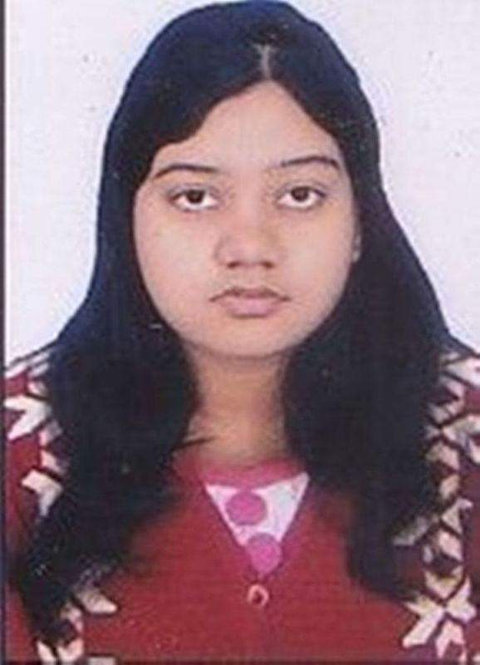
Address : 14A/4/25- SEPCO TOWNSHIP
DURGAPUR- 05
DIST- BURDWAN
STATE- WEST BENGAL
PIN- 713205
Mobile No : 8972594496

E-mail :mondal.aditi6@gmail.com

Career Objective:

My aim is to be placed with a well reputed organization like yours so that I can gain knowledge to greater extent. And my long term aim is to enhance my carrier with the knowledge gained.

Academic Qualifications:

Degree | Institute | Department | Board /  University | Year of  Passing/Appearing | Aggregate % / DGPA
M.Tech | Dr. B.C.Roy Engineering College | Electronics & Communication Engineering | M.A.KA.U.T. | 2018 | 7.54
B.Tech | Bengal College of  Engineering and Technology  for Women | Electronics & Communication Engineering | M.A.K.A.U.T. | 2016 | 7.77
H.S. | Bidhan Chandra Institution For Girl’s | Science | W.B.C.H.S.E | 2009 | 63.20
I.C.S.E. | Pranavananda Vidya Mandir | General | C.I.S.C.E. | 2007 | 62.43

WORK EXPERIENCE:

Name of Organization | POST | Duration
HDB FINANCIAL SERVICES( HDFC BANK ) | SALES EXECUTIVE | 16.08.2018- 01.04.2018

Trainings:

Name of Institute / Organization | Training Title | Duration
INFYTEL | Scholar @ NETWORKING | 21.06.2014-31.07.2014
PRASAR BHARATI | Terrestrial Television Transmission System & Technique | 10.06.2015-24.06.2015
DURGAPUR YOUTH COMPUTER TRAINING CENTRE | HTML | From January to June,2014

Projects:

- Mini Project in B.Tech- ELECTRONIC SWITCH FOR PHYSICALLY CHALLANGED PERSON USING RELAY,EMERGENCY LIGHT USING LED
- Final Year Project in B.Tech-WIREHOUSE LINE ROBOT USING SENSOR AND DTMF
- Final Year Project in M.Tech- STUDY OF A SLOTTED MICROSTRIP ANTENNA

Additional Qualification / Achievements / Certifications:

- CERTIFICATE OF EXCELLENCE on Robotics & Computer Applications Institute of USA Technophilia.

- ONE DAY SEMINAR ON FRONTIES OF TECHNOLOGY on Mobile Technology, Robotics & Intelligent Systems.

Subjects of Interest:

- Digital Electronics
- Electromagnetic Field Theory
- Communications

Computer Proficiency:

- Basic Computer Knowledge
- C, JAVA, Advanced Networking, DBMS,HTML
- Strengths:

- Hard Working.
- Honest.
- Management capability.
- Good at working in a team.
- Eagerness to learn new things.

Hobbies:

- Reading Books.
- Singing.
- Watching Movies.
- Travelling.

Personal Details

- Languages known : English, Bengali, Hindi
- Date of birth: 26th July,1991
- Gender: Female
- Blood Group: O+
- Marital Status: Married
- Nationality: Indian

Declaration:

I hereby declare that the above-furnished information is true and correct to the best of my knowledge and belief.

Signature

