RESUME

Bhuvnesh Singh Yadav  Mobile No: +91-9589486406  Email: bhuvneshsinghyadav@gmail.com  Address:  Tulip 517 New Minal Residency,J.K.Road  Bhopal,M.P.-462023 | 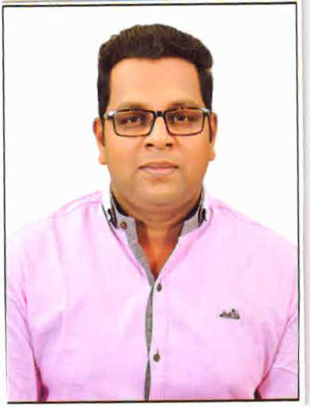

Career Objective
To achieve such a position in an organization having core values and innovative vision, where my performance and technical skills substantially contribute in the integrated growth of both the organization and my career.

Academic Qualification

M.Tech in Computer Science and Engineering from Shree Institute of Science and Technology (R.G.P.V) with an aggregate of 81.60% in year 2015.

Bachelor of Engineering in Computer Science and Engineering from All saints College of Technology (R.G.P.V.) with an aggregate of 79.65% in year 2011.

Higher Secondary with 75.1% (Math’s stream) in year 2006-07 from M.P. Board.

High School with 65.6% in year 2004-2005 from M.P. Board.

Experience

Five Year Experience in teaching core subjects in C.S. branch (M.C.A,B.C.A) in M.C.E.E, Bhopal.

Presently Teaching in Destination Coaching Institute Bhopal(Taking C,C++,JAVA(CORE), Mtech Maths ,TOC,CD,ADA,CGM,OR-COOT(M.C.A) ).

Teaching :- Maths 6 to 12 Class.

Working Area :- Teaching,Career Counselling Admissions -Registration, Verification.etc

Training

Major Training (6 weeks) Website Designing from Centre for Research and Industrial staff Performance (CRISP), Bhopal (M.P.).
Minor Training (2 weeks) Computer Network from Focus Education and Consultancy, Bhopal(M.P.).

Projects

1. Major Project : BIT TORRENT PROTOCOL
Team Size : 02 members.
Technologies : JAVA
Description : The objective of this software is to reduce network traffic by 27-55% from a downloading as well as not stop working even file is missing during downloading or file position change within execution of BIT TORRENT protocol is running.
Responsibilities : Programming and concept designing.

2. Minor Project : TASK SCHEDULER.
Team Size : 02 members.
Description : The objective of this software is to create a virtual human means you don’t sit infants of System. When program is run with help of timer that we give instruction those task that we execute it. Then sequence of task assign that can be run, without human is sit infant of .system start automatically.

Strengths
Never give up attitude.
Strong desire to learn.

Hobbies
Learning from peoples and good books
Visiting Adventures places.
Making communication network.

Personal Details

Candidate’s Name : Bhuvnesh Singh Yadav
Father's Name : Mr. B.S. Yadav.
Date of Birth : 19/09/1988
Permanent Address :Tulip-517, New Minal Residency J.K Road Bhopal, (M.P.) 462023.

Declaration

I hereby declare that the above-mentioned information is correct up to my knowledge and I bear the responsibility for the correctness of the above-mentioned particulars.

PLACE: BHOPAL (BHUVNESH SINGH YADAV)
DATE:

