R E S U M E

PERSONAL DETAILS :
NAME : HARBINDER SINGH 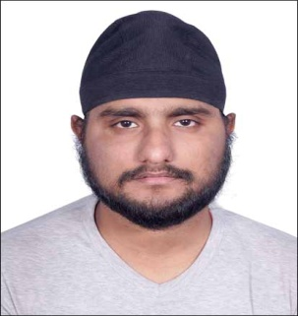
ADDRESS: 83/2 BANAMALI NASKAR ROAD ,KOLKATA – 700060.
DATE OF BIRTH : 22/08/1995
GENDER : MALE
CONTACT NO. : 9748960989
E-MAIL ID. : harbindersingh983@gmail.com

OBJECTIVE : To continuously enhance my knowledge, skills and experience by getting involved in challenging work environment and utilize them for personal and organizational growth to the best of my ability.

ACADEMIC QUALIFICATIONS :
DEGREE/COURSE | INSTITUTION | BOARD/UNIVERSITY | YEAR OF PASSING | AGGREGATE/CGPA
B-TECH IN CIVIL ENGINEERING | NETAJI SUBHASH ENGINEERING COLLEGE | M.A.K.A.U.T. | 2017 | 8.88
HIGHER SECONDARY | D.A.V. PUBLIC SCHOOL | C.B.S.E. | 2013 | 91.40
MADHYAMIK | D.A.V. PUBLIC SCHOOL | C.B.S.E. | 2011 | 9.40

ADDITIONAL QUALIFICTION/ACHIEVEMENT/CERTIFICATIONS :
- QUALIFIED RRB JE PRE
- MISSED SSC JE PRE BY 0.38 MARKS
- GATE AIR-753 IN 2019 AND QUALIFIED 4 TIMES.
- SELECTED IN RITES AS AE
- PSPCL JE RANK -54
- QUALIFIED APPSC AE PRE
- COLLEGE TOPPER IN 1ST YEAR WITH CGPA 9.43

SUBJECTS OF INTEREST: SOIL,RCC,SOM,FLUID,IRRIGATION,STEEL,OCF,TRANSPORT,SURVEY.
STRENGTHS : HARD WORK,ADAPTABILITY,HONEST,QUICK DECISION MAKING.
LANGUAGES KNOWN : ENGLISH,HINDI,PUNJABI,BENGALI.

