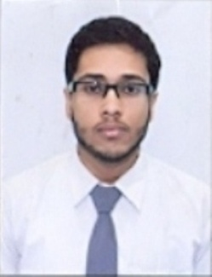
Curriculum Vitae
Personal details:
Name : Arghadip Mukherjee
Father’s Name : Arobindo Mukherjee
Address : 309 Panchanan Tala road kolkata
Mobile : 8777549364
Email id : mukherjeearghadip028@gmail.com
Date of Birth/Age : 20/07/1997 / 22 years
Marital Status : Single
Languages Known : Bengali, Hindi and English fluent in all respect.
Computer Knowledge : Word ,Excel, Powerpoint
Identification Details : Adhar Card,Pan Card.
Educational Qualification:
Examination | School/College | Year | Degree/Remarks
Madhyamik | Shri Ritam Vidyapith | 2013 | Pass(88.28%)
Higher Secondary | Jodhpur Park Boys’ School | 2015 | Pass(83.2%)
Graduation | Vivekananda College | 2018 | Bachelor of Science

Resume : I have always felt that it is the difficult level of work, which makes it interesting, conversely there is no joy in work, which any person can do. Also, each successive work must be done better than the previous one, for without improvement there cannot be progress.

