CURRICULUM VITAE  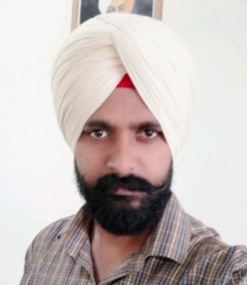  Gurpreet Singh  Contact Information:  Address:  VPO Chural kalan Tehsil Lehra  Distt. Sangrur (PB)  Mobile –9306165009  Residence –9780556004  E-Mail:  Bajwa6004@gmail.com  Personal Data:  Date of Birth : 13/05/1986  Father’s Name: Mr. Partap singh  Mother’s Name: Mrs. Kamla  Father s Occupation : Ex Serv.(PP)  Sex : Male  Nationality : Indian  Languages  Known : English,  Hindi, Punjabi  Hobbies : Reading Books  Playing cricket | Objective  To make my career in a professional and leading organization excels my professional growth while putting up all my efforts towards the commitment to the organization.  Professional Qualification  M.sc MATHEMATICS in 2012 (Regular) from DOABA COLLEGE Jalandhar (GNDU AMRITSAR)  B.Ed from Milkha Singh Educational Institute Bareta  Academic Qualification  Professional Skills  - MS-WORD  - MS-EXCEL  - MS-POWER POINT  EXPERIENCE  - 1Year and 6 Month experience in VIDYA RATTAN POLYTECHNIC LEHRAGAGA as a MATH LECTURE FROM AGUSAT 2012 TO JAN. 2014  - JAN 2014 TO JULY 2014 Work as a PGT MATH in COLONEL SEN SEC. PUBLIC SCHOOL CHURAL KALAN (SANGRUR)  - JUNE 2015 TO DEC. 2018 work as a Managing Director cum Lecture (Math) 9th to 12th at ROYAL ACADEMY JAKHAL  - Jan 2018 to till date Work as a Managing Director cum Lecture ( Math) 9th to 12th in NEW KOTA CLASSES JAKHAL
  Qualification | Board | year | Percentage
  B.A | Pbi. Uni | 2010 | 56%
  B.Ed | Pbi. Uni | 2015 | 77%
  10+2 | P.S.E.B | 2006 | 63%

Extra Curricular
2 Year diploma in Art & Craft from Govt. Institute of Art Nabha Punjab
Achievements

PSTET (MATH & SCI.) CLEAR
Reference
Advertisement in News paper

Declaration:
I hereby declare that the information furnished above is true to the best of my Knowledge.

Place: CHUARL KALAN (PUNJAB)
Date: GURPREET SINGH

