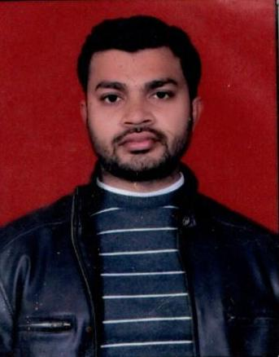

EBADUR RAHMAN Add: MOLVI TOLA BUDAUN UP 243601 CELL: +91- 9084001486,
E-mail Id – ebadur.rahman74@gmail.com
CURRICULUM VITAE

Career Focus:
CURRICULUM VITAE
To encounter all challenges of competitive environment and to explore all opportunities to exploit the best of my knowledge and to pursue a career leading to professional development in a progressive organization, that values its human resources and rewards performance by employing all my potential, skills and proficiencies.
ACADEMIC QUALIFICATIONS

- B.Sc (PCM) Passed From M J P R UNIVERSITY BAREILLY
EXPERIENCE
- Worked as Math Teacher from 3-March-2011 to 30-Sept-201 at S M Junior High School in Budaun.
- Worked as Asst. Teacher from 8-Oct-2014 to 5-Dec-2016 at Green Wood Public School Budaun.
- Worked as Math Faculty from 12-Apr-2017 to 19-July-2019 at Mahendra Educational Pvt. Ltd.

SKILLS

KEY SKILLS:

- Excellent with Presentation Skills
- Communication Skills
- Interpersonal Skills
- Time Management Skills
- Proficient in Microsoft Office with modern Technology

EXTRA- QUALIFICATION

- Good Knowledge of Computer including MS Word, MS Excel, MS PowerPoint, Internet etc.

PERSONAL

DETAILS
Name of Mother - SHAHEEN RAHMAN
Name of Father - ABDUL RAHMAN
Date of Birth - 01 – JULY - 1992
Gender - Male
Marital Status - Single
Nationality - Indian
Hobbies - Doing exercises, playing & watching Sports and Games
Language(s) - English, Hindi, Urdu

DECLARATION
I hereby declare that the above mentioned information is correct up to the best of my knowledge and belief. I bear the responsibility for the correctness of the above mentioned particulars. I will leave no stone unturned to do my best.

Date:
Place: Budaun (U P) Ebadur Rahman

