CURRICULUM VITAE

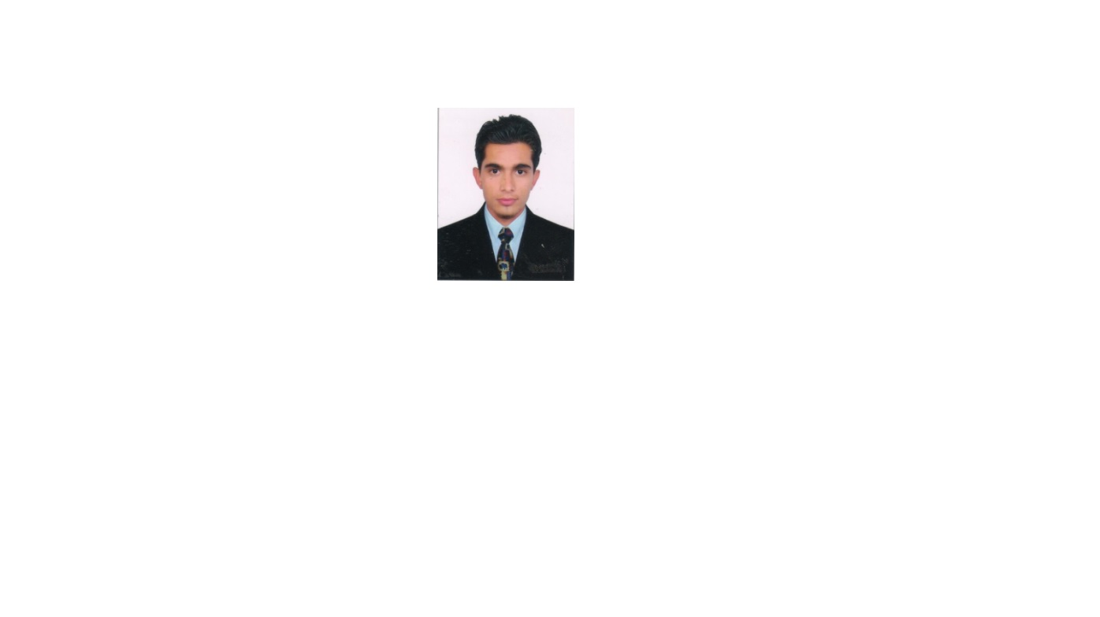
Gurpreet Kumar
V.P.O Bhaura
Distt.SBS Nagar (Punjab)
Pin Code – 144506
Email:gurpreetkumar623@gmail.com
Phone No: +91-9041766023

CAREER OBJECTIVE
To obtain the challenging task in an esteem organization and prove my abilities, hard work, dedication and honesty.
EDUCATIONAL QUALIFICATIONS
Degree / Institution/ Year Percentage
Certificate Board
B.Tech ECE Lovely Professional University 2014 62.55%
Phagwara

SSC Govt. Sen. Sec. School, 2010 72.62%
Nawanshahr (PSEB)
HSC Govt. High School, 2008 74.67%
Surapur (SBS Nagar) (PSEB)

INTERNSHIP
Organization: Telecoma Technology Pvt. Ltd. Mohali (Punjab)
From June 3, 2013 to July 12, 2013

Objective:
• To study telecommunication network
• Configuration and maintenance of BTS

Organization: BSNL Nawanshahr (Punjab)
From June 1, 2012 to June 28, 2012

Objective:
- Maintenance of internal system
- Resolve the problems of customers
CERTIFICATION
Certified Course in CB & Adv. MS Office ISO 9001:2015
Certificate in Sales Marketing

LANGUAGES KNOWN:
English, Hindi, Punjabi
HOBBIES:
Playing Cricket, Reading Newspaper
PERSONAL DETAILS
Mother’s Name: Mrs. Kulwinder Kaur
Father’s Name: Mr. Surinder Pal
Date of Birth: 16 – 11 – 1992
Gender: Male

Martial Status: Single

DATE:
PLACE: Gurpreet Kumar

