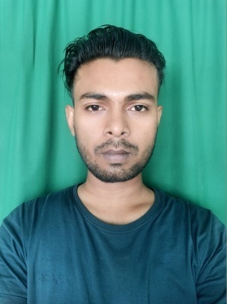  Contact details  ✆ 7640848151  ✉ vsahani984@gmail.com  Personal Details  Name : Vikash Kumar Sahani  Father Name : Kishori Sahani  Mother Name : Kamli Devi  D. O. B : 26/02/1999  Gender : Male  Nationality : Indian  Marital Status: Unmarried  Languages Known: English, Hindi, Bhojpuri.  Present Addres: C1-2, Guru Nanak Pura, Near Nirman Vihar Metro Station, Opposite V3S Mall, Laxmi Nagar, New Delhi, Delhi 110092  Permanent Address: Vill-Sahtha, PO-Sahtha,PS-Bhagwanpur, District Vaishali,State Bihar  Hobbies  Sports  Listening to music  - Dancing  - Drawing  - Painting  Skills  - Written and communication skills.  - Ability to deal with people diplomatically.  - Willingness to learn.  - Able to Work independently and with the team.  - Proficiency in: Fundamentals , Window 7,Dimensions Of IT, MS Office (Word, Excel, PowerPoint) Tally-9, Email, Internet, Adobe Photoshop, Ms-Access, Page Maker, C++,SQL Server, Visual Basic, Overview Of Hardware. | OBJECTIVE  To secure a challenging position in a reputable Organization to expand my Learning, Knowledge and Skills.  QUALIFICATION  OTHER QUALIFICATION  ADVANCED DIPLOMA IN COMPUTER APPLICATION(ADCA)  ABOUT MY SELF  I am very Practical Person with an Amiable Disposition and Strong Cultural values. I strongly believe in Accuracy and Precision in whatever I do. I believe I have good communication skill that would provide transparency and productivity in the Organization.  STRENGTH  - Communication  - Self Motivated  - Organization Skill  - Flexibility and Adaptability  - Learning Agility  - Decision Making Skills  - Creativity  - Team Work  - Loyalty  - Leadership  - Responsible  - Listening  Declaration  I hereby declare that all the details furnished above are true to the best of my knowledge and belief.  DATE: SIGNATURE
  QUALIFICATION | BOARD/UNIVERSITY | COLLEGE/INSTITUTE | YEAR OF PASSING
  10TH | CBSE | KVS PASIGHAT | 2015
  12TH COMMERCE | CBSE | KVS PASIGHAT | 2017
  GRADUATION  B.COM | RGU | JNC PASIGHAT | 2020
RESUME

