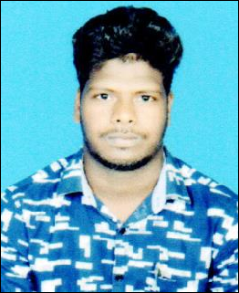CURRICULUM VITAE

SAROJ KUMAR MAHARANA S/O: RAMESH MAHARANA
AT- PLOT NO – 245, LANE-1, DUMUDUMA PO- DUMUDUMA, BHUBANESWAR
PS-KHANDAGIRI DIST-KHORDHA PIN -751019
MOB-7008648522
E-mail- msarojkumar42@gmail.com

CARRIER OBJECTIVE

1. To become a part of your reputed and esteemed organization and serve you with best of my skills to give you satisfaction up to your expectation related to area of my work and skills.
EDUCATIONAL QUALIFICATION

Sl.  No. | Examination Passed | Board/University | Session | Division/CGPA
1. | 10th | B.S.E, Odisha | 2013 | 1st
2. | +2 | CHSE, Odisha | 2015 | 2rd
3. | +3 | UTKAL University | 2018 | 2nd
4. | MBA | GIFT | 2020

EXTRA QUALIFICATION
PGDCA

EXPERIENCE

- 1 year teaching Experience in subject Banking Awareness, Economics & Current Affairs at OICI Institute, Baripada.
- 1 Year Teaching Experience in subject Banking Awareness, Economics & Reasoning at ICP Institute, Bhubaneswar.

- 8 month teaching Experience in subject Banking Awareness, Economics & Current Affairs at VANIK Institute, Bhubaneswar.
HOBBY

- Watching Discovery
- Reading Newspaper.
- Playing Cricket

STRENGTH

- Positive Attitude.
- Very Hard working always ready to face new challenge & very keen to learn & experiment with new project.

PERSONAL PROFILE
Name : SAROJ KUMAR MAHARANA
Father’s Name : RAMESH MAHARANA
Date of Birth : 04.06.1998
Sex : Male
Nationality : Indian
Religion : Hindu
Category : General
Marital Status : Unmarried
Language Known : English, Hindi, Oriya

DECLARATION

I hereby declare that the above mentioned information is true to the best of my knowledge and belief. If any information mentioned above is found to be false then my candidature may be cancelled.

Date :

Place : Saroj Kumar Maharana

