CURRICULUM VITAE 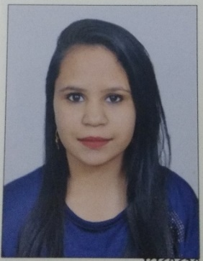
KAJOL

kajolbotham2@gmail.com

Contact no. 8130385025
CAREER OBJECTIVE

TO WORK IN AN ENVIRONMENT WHERE I CAN APPLY MY TECHNICAL SKILLS AND ENHANCE EXISTING KNOWLEDGE TO GAIN MAXIMUM EXPOSURE TO THE CURRENT TRENDS IN MY FIELD THEREBY ACHIEVING BOTH MY PROFESSIONAL AND ORGANIZATIONAL GOALS.

ACADEMIC CREDENTIALS

Qualification | Board/University | Year | CGPA/Percentage
M.A (Hons) | SCHOOL OF OPEN LEARNING | 2016-2018 | ------
B.A (Hons) | DELHI UNIVERSITY | 2013-2016 | 61.45
INTERMEDIATE | CBSE | 2013 | 84.4%
MATRICULATION | CBSE | 2011 | 51.3%

TECHNICAL SKILLS

➢ MS WORD
➢ MS EXCEL
➢ MS POWERPOINT
➢ MS OUTLOOK
➢ GALILEO
➢ FIDELIO

GENERAL SKILLS

GOOD COMMUNICATION SKILL

1. ADAPTIVE AND FLEXIBLE
2. LEADERSHIP
3. TEAM PLAYER

CAREER SKILLS

RECENTLY COMPLETED “POST GRADUATION DIPLOMA IN AVIATION” FROM FRANKFINN INSTITUTE OF VOCATIONAL TRAINING.

SUBJECTS THAT ARE THE PART OF THIS COURSE :

1. AVIATION
2. HOSPITALITY
3. GROOMING
4. TRAVEL
5. PERSONALITY DEVELOPMENT

PROFESIONAL EXPERIENCE

- FRESHER

KEY SKILLS

- Calm personality with well honed customer service skills.
- Charismatic and confident public speaker.
- Posses excellent communication and presentation skills.
- Proficient in handling multiple tasks.
- Excellent planner, adaptable, regular and punctual.
- Disciplined, punctual and responsible.
- Ability to work in a team.
- Hard working, sincere and faithful.
- Positive outlook to inspire others.

PASSPORT DETAILS

PASSPORT NO: R5610992

PASSPORT ISSUED FROM: NEW DELHI

PASSPORT VALID FROM: 07/12/2017

PASSPORT VALID TILL: 06/12/2027

PERSONAL DETAILS

➢ Father’s Name: Ajay Kumar
➢ Permanent Address: 18, Church Lane Jangpura Bhogal, New Delhi
➢ Date of Birth: 26/06/1995
➢ Languages Known: Hindi and English
➢ Marital Status: Unmarried
➢ Gender: Female
➢ Interest & Hobbies: Like to meet new people, Travelling, Helping others,
and photography.

DECLARATION

I hereby declare that all the information furnished above are true, complete and correct to the best of my knowledge and belief and will be supported by original documents whenever required.

Date:

Place: (KAJOL)

