Resume

KARN DEEP RANJAN
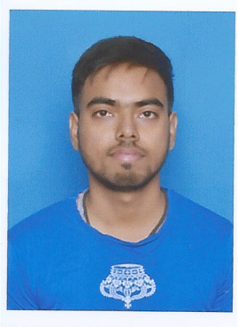assport sized colour photo not larger than 2 x 2
Address - Sector-5C, Quarter No- 1079
Bokaro Steel City, Jharkhand
Email id - cool.karn122@gmail.com
Mobile No.- +91 8668499228

SUMMARY

- B.E in Electronics &Telecommunication from International Institute of Information Technology, Hinjewadi, Pune.

ACADEMIC PROFILE

Degree/ Certificate | University / Board | College / School | Year of Passing | Percentage / CGPA
B.E. - (E&TC) | Savitribai Phule Pune University | International Institute of Information Technology, I²IT, Pune | 2019 | 6.14
XII | CBSE | M.G.M.Higher Secondary School | 2014 | 70.8%
X | CBSE | M.G.M.Higher.Secondary.SCHOOL | 2012 | 85%

ACADEMIC PROJECTS

- “Smart Door Locking System”
Team Members – 3, Duration of Project – 6 months
Summary– A smart door lock system for home automation. A door lock system is equipment that uses the digital information such as a secret code & smart card (RFID tag) as the method for authentication instead of the legacy key system.

- “Techathon-2016”
Team Members – 5, Duration of Project – 2 days
Summary– Smart Door Mat as its name suggests, a computer-powered door mat , that will detect visitors. It’s a pressure-sensitive layer of smart foam that you can set under your doormat or pretty much anywhere in your home you want pressure-sensitive responses.

INTERNSHIP

- Steel Authority Of India Limited (Dec 2017 – Jan 2018) – Vocational Traniee

HONOURS & AWARD RECEIVED

- National Sudoku Championship 2017 – AIR-37 – AY-2016-27
- National Sudoku Championship 2018 – AIR 36 – AY-2017-18

EXTRA-CURRICULAR ACTIVITIES

- Volunteered for the “Blood Donation Campaign” at I²IT. Took on the responsibility to spread awareness among the professionals working in organizations in the vicinity of the college.
- An Organizer in Committee Member for “Dhruva 2017” – I²IT’s annual inter-college student fest held in campus.
- Team Leader and Owner of MARTIAL WARLOCKS – Currently in ESL India Premiership 2019 Masters Cup.( https://pro.eslgaming.com/india/brawl-stars-2/teams/ )

PERSONAL INFORMATION

- Strengths
  - Strong analytical mind
  - Good communication skills
  - Self-Motivated & Optimistic
  - Adaptable with new Environment and technology
- Languages known
  - English
  - Hindi
- Date of Birth – 06 Nov 1995
- Hobbies – Playing PC & Mobile Games, Creating & Solving Sudoku, Music, Travelling & Cardistry.

Currently Preparing for Govt. Exams RBI Assistant 2019, SSC CGL 2019, SBI Junior Assosciate 2020 and PGDBA 2020.
CAT 2019 – LRDI- 76.73 Percentile.

