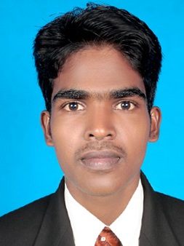
PRAMOTH P
Permanent Address:
4-46, Kollanchi,EttenKattu Vilai ,
Mulankuzhi po,
Kanayakumari-629162,
TamilNadu, India.

Email: pramothp1991@gmail.com Phone: (+91) 9791639151

Self Introduction:

Since graduation in 2013 and completion of one year GAT (Gradute Apprentice Trainee), I have been preparing for SSC Exams like SSC CGL, SSC CHSL, SSC MTS & SSC JE, With this appearances, I’m acquainted with SSC exam patterns and their levels. Also focusing on TNPSC related exams. Still I’m focused on cracking the exam. I can utilize my skills and knowledge efficiently for Organization growth and enhance myself further.

Educational Qualification:

Course | Institution | Board/  UNIVERSITY | Percentage of Marks/CGPA obtained | Year of passing
B.E | Udaya School of Enginering.  Nagercoil , kanayakumari. | Anna University | 8.59 | 2013
XII | Vidhya Jyothi Matric Hr.  Secondary school, Nagercoil. | State Board | 80.00 | 2009
X | Vidhya Jyothi Matric Hr.  Secondary school, Nagercoil. | State Board | 70.00 | 2007

EXAM EXPERIENCE:

- SSC CGL- 2016
- SSC CHSL -2016
- SSC CHSL – 2017
- SSC MTS – 2016
- SSC JE – 2016
- RRB exams-2018
Cleared in ssc mts tier 1**
Cleared in rrb alp tier 1**

Exam | Year | Score | Cut-off
SSC mts tier 1 | 2016 | 114/150 | 122/150
SSC chsl tier 1 | 2016 | 90/200 | 120/200
SSC JE tier 1 | 2016 | 95/200 | 139/200
SSC chsl tier 1 | 2017 | 102/200 | 139.5/200
RRB group - D | 2018 | Result pending
RRB ALP | 2018 | Result pending

UPSC :

Undergone UPSC 2017-2018 Batch coaching in TEMPZ ACADEMY,
Anna Nagar west , Chennai.

AWARDS :

- Toppest percentage during the year 2010-2011
- Got anna university rank of 36th.

SOFTWARE SKILLS:

Photoshop
MS Office (word, excel, power point)

Declaration:

I do hereby declare that the particulars of information and facts stated here in above are true, correct and complete to the best of my knowledge and belief.

