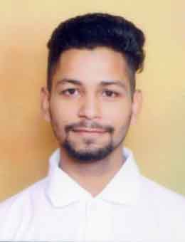

MOHIT SADANA
Contact no:91-8054443565
Email id: mohit31802@gmail.com
Indrapuri, near arya colony,Samana, Distt.patiala,Punjab,147101

OBJECTIVE

To work for an organization which would provide me the opportunity to improve my skill and knowledge to growth along with organization.

EDUCATIONAL QUALIFICATION

Level/Board | College | C.G.P.A/PERCENTAGE
B.E(MECHANICAL) | Chandigarh University Mohali | 7.78 C.G.P.A
Class XII(P.S.E.B) 2014 | Public Collegiate Senior Secondary school, Samana, | 68.4%
Class X(P.S.E.B) 2012 | Dayanand Model High School, Samana | 77.15%

TECHNICAL SKILLS

- AutoCAD
- Fabrication
- Welding

TRAINING & EXPERIENCE

- 6 Weeks Industrial Training at Sagar Engineering.
- Workshop of designing and manufacturing of SAEINDIA Supra(2018)
- 6 Week Workshop training in Chandigarh University.
- 6 Months teaching experience.
ND
PROJECTS

Type Of Project | Project Name | Role
Major Project  (2018) | SAE SUPRA | Team Member  Steering module  Fabrication
Major project  (2017) | GO-KART | Team Member  Engine module  Fabrication
Minor Project  (2016) | WIND TURBINE | Fabrication

CERTIFICATION & AWARDS

- Association membership in SAEINDIA

- Certificate of participation in IGKC LPU SAEINDIA COLLEGIATE CLUB

- Certificate of participation in SAEINDIA SUPRA

INTERPERSONAL SKILLS

- Positive Attitude
- Determined and Focused
- Excellent Team Work
- Flexible

HOBBIES/INTERESTS
- Fitness & Sports Enthusiast
- Music
- Travelling
PERSONAL DETAILS

- Father’s Name : Rajesh Kumar
- Mother’s Name : Sujata
- D.O.B : 15 August 1996
- Sex / Marital Status : Male / Single
- Language Proficiency : English, Hindi, Punjabi.

I do hereby declare that the above information is true to the best of my knowledge.

Place:______________

Date:_______________ Mohit Sadana

