CURRICULUM VITAE
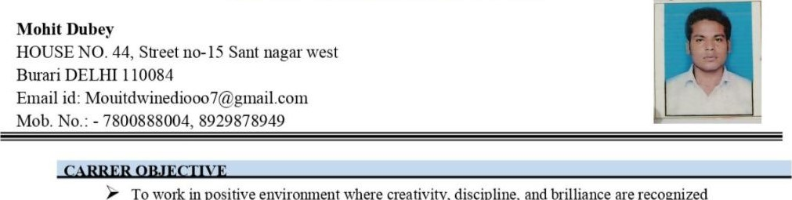
To
in
positive
where
creativity,
discipline,
are
recognized
andhandsomely rewarded.
I am leliable, well-organized, and used to working on my own initiative. I am able to afford my workload and am comfortable working on my own as part of a team.
- 10th (UP Board)
- 12th (UP Board)
- B.SC(Awadh University Ayodha)
- M.A(DeIhi University)
- B.PE (Final)
- U.P.S.C (Interview Returned)
WORK FXPFBIFNCE:-
- Work as HR in Human Resource Department and Management. Five Years' Experience in Teaching Sector.
- DCA . O Level
- I am cheerful, quite punctual of time, and believe in self and the almighty, Having the zeal to face challenges.
- Having good communication skills.
- Imovation
- Exploring New Place in Nature
- Reading Book
• | Father's Name | • Mr.Ragunath Dubey
• | Date ofBi1th | : 07/08/1998
• | Sex | Male
• | Marital Status | : Unmarried
 | Nationality | Indian
 | Language Known | • Hindi , English & Awadhi
DECLARATION
- I hereby declare that the above statement is true to the best of my knowledge & belief.
Date:
Place: (Mohit Dubey)

