CURRICULUM VITAE
NAME: SOUMYADIP HUI  EMAIL ID: soumyadiphui87@gmail.com  CONTACT NO: 9609479056/8918728769 | 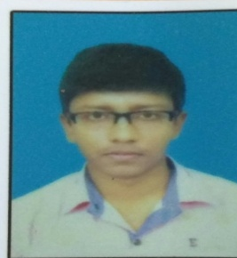

About myself: I believe that I’m a hard worker, self motivated with a good sense of responsibility and organisation.

Objective: As a B.Tech engineer in the Electrical stream I would like to be a part of a reputed organisation as yours where I would be able to gain personal experience and grow as a professional.

ACADEMIC QUALIFICATIONS:
CLASS | BOARD | INSTITUTION | YEAR OF PASSING | MARKS OBTAINED
B.TECH | MAKAUT | M.C.K.V.I.E | 2015-2019 | 7.91 cgpa
12th Standard | W.B.C.H.SE | D.H.S.V | 2015 | 80.4%
10th Standard | W.B.B.S.E | D.H.S.V | 2013 | 86.57%

Proffesional proficiency:
- Vocational training during the period from 12th June 2018 to 1st July 2018 at S.E.RLY. WORKSHOP, KHARAGPUR.
- Workshop On “ INDUSTRIAL AUTOMATION (PLC and SCADA)” Organised by IET,UK,KOLKATA Network.

Language proficiency:
1.ENGLISH: Read,Write,Speak

2.BENGALI: Read,Write,Speak

3.HINDI:Read,Speak

Personal Details:
Father’s name: Anjan Kumar Hui
Mother’s name: Sonali Deb Hui
D.O.B: 8th July ,1997
Permanent address: Vill+P.O- Debra, Dist-West Medinipur, pin-721126, West Bengal.
Nationality: Indian.
Gender: Male
Marital status: Single

Declaration:
I hereby declare that all the above mentioned details are true according to the best of my knowledge.
Date: 09/08/2019

Soumyadip Hui

