RESUME
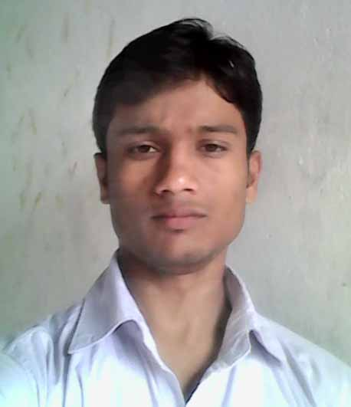
Rajeev kumar Dubey
S/O Mr.Pradeep Kumar Dubey
Add - Rajeev gandi nager
Farrukhabad(U.P.)
Mob-9956815872
Email- dubeyraj918@ gmail.com

CAREER OBJECTIVE:-
- To work for an organization which could provide competitive environment and opportunity for professional as well personal growth.
ACADEMIC QUALIFICATION:-
- High school Passed from U.P. Board Allahabad in 2008.
- Intermediate (PCM) passed from U.P. Board Allahabad in 2010.
- B.Sc (PCM) Dr.B.R.A.University Agra in 2014
EXTRA QUALIFICATION:
6th Month Computer basic
COMPETITION EXAM QUILIFIED
I started preparation for Gov Exam from 2014 & Qualified
some exams written SSC ( CGL ,CHSL) RRB NTPC , ESIC UDC
PERSONAL INFORMATION:
Name Rajeev Kumar Dubey
Father Name Pradeep Kumar Dubey
Date of Birth 10/05/1993
SEX Male
Language Known Hindi English
Marital Status An married
Category Gen
DECLARATION:-

The Information provided above is true of the of my Knowledge
Date 15/10/2019 Signature
Place – Farrukhabad Rajeev

