Education

Bhawana Pancholi
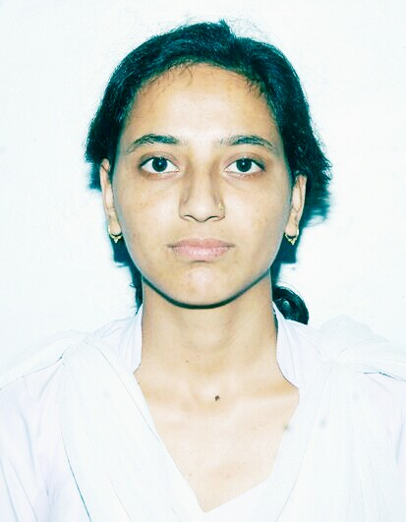
Photo

PERSONAL DETAILS CONTACT DETAILS

D.O.B :- 27-03-1992 Mob No :-8449508109
Gender :- Female Email :- bhawanapancholi15@gmail.com

Languages: - Hindi, English,Punjabi
Father’s Name :- Mr. J.C. Pancholi
Permanent Address :- Street no.- 2, Akal sahai nagar, near mungi dairy
Mundian Kalan , Ludhiana, Punjab- 141015

Qualification | Institute | Board | Year | Percentage / CGPA
M.Tech (Thermal) | GBPUA&T, Pantnagar | GBPUA&T | 2017 | 79
B.Tech (Mechanical) | BTKIT, Dwarahat | UTU | 2014 | 72
XII | J.N.V. Tarikhet, Almora | C.B.S.E. | 2009 | 80.4
X | J.N.V. Tarikhet, Almora | C.B.S.E. | 2007 | 80.8

Trainings
Company Name, Location July 2013 – Aug. 2013

- Implant Training From Ashoka Leyland Plant, Rudrapur

Skills
- CooperativePositive attitude towards work
- Ready to take responsibility
- Curious to learn
- Capable of adapting to any situation

Technical Skills
- Auto Cad

Certifications
- Certified by CADD CENTRE for completion of AUTO CAD software ccour
Achievements & Extracurricular Activities
- Participation in hospitality Committee Aarohan’12 Techfest, Uttarakhand Technical University.
- Merit Scholarship under Education Scholarship Scheme for Army
- First prize for NATIONAL YOUTH PARLIAMENT COMPTITION AT REGIONAL LEVEL
- Third prize for NATIONAL YOUTH PARLIAMENT COMPTITION AT NATIONAL LEVEL
- Handball, chess, kabbadi,badminton and table tennis

Key Projects (Final Year Projects)
- Study and Fabrication of Horizontal Axis Wind Turbine
- Thermal analysis of rod in Anysys
- Study the performance and emission characteristics of CI engine runnning on different blends of biodiesel from waste cooking oil with diesel

DECLARATION
I hereby declare that the above written particulars are true to the best of my knowledge and belief.

Bhawana pancholi
PLACE: - Pantnagar SIGNATURE OF CANDIDATE

