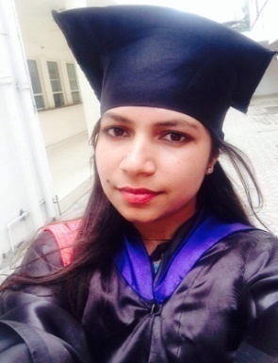

Radhika Bhardwaj
E-mail- official.radhika123@gmail.com
Phone No-9569942162

PROFESSIONAL EXPERIENCE
* Lecturer, Kanya Maha Vidyalaya
January 2015-April 2015.
* IELTS Trainer, Grey Matters
April 2017- December 2018

SKILLS

EXTRA CURRICULUM
- Completed certified course of ‘Microsoft Excel 2010’ from Alison.com.
- Completed course of ‘PERSONALITY DEVELOPMENT’ from KMV.

- 45 Day Course of ‘WEB DESIGNING’ from software development cell, KMV.
- Participated in ‘TEST YOUR TECHNICAL SKILLS’ in intercollegiate competition held at ‘sports college Jalandhar’.
- Appeared in ‘National Cyber Olympiad’.

SEMINARS AND CONFERENCES ATTENDED

- 2 Day Workshop on ‘ETHICAL HACKING AND CYBER SECURITY’ by hackingteacher.com.
- 2 Day National seminar on ‘SOCIAL IMPLICATIONS OF ARTIFICIAL INTELLIGENCE’.
- 2 Day International Conference on ‘ROLE OF TECHNOLOGY IN ENHANCING THE QUALITY OF HIGHER EDUCATION’.
- 2 Day International Conference on ‘EMPOWERING WOMEN THROUGH HIGHER EDUCATION’.

Class | Year of Passing | Board/University | Institute | (%)Percentage
MSC.CS | 2014 | GNDU | Kanya Maha Vidyalaya | 70%
BCA | 2012 | GNDU | Kanya Maha Vidayalya | 66%
10+2 | 2009 | P.S.E.B | KMV Collegiate Sr.Sec.School | 81%
10 | 2007 | P.S.E.B | Jullundur Model Sr.Sec.School | 74%
ACADEMIC QUALIFICATION

* Merit Holder in 10+2 class.
* Scored 7.5 in IELTS Test.

PERSONAL DETAILS

1

I hereby declare that the information given is true and the best of my knowledge and believe.

DATE: - SIGNATURE:-

