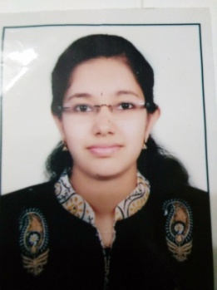
PERSONAL INFORMATION
NAME: DEVI.K
FATHER’S NAME : BHASKARAN K
DATE OF BIRTH: 16-08-1994
NATIONALITY: INDIAN
PERMANENT ADDRESS : CHAITHRAM (H), PALOOR, PULAMANTHOLE (PO),
MALAPPURAM DT,679323.
CONTACT ADDRESS: CHAITHRAM (H), PALOOR, PULAMANTHOLE (PO),
MALAPPURAM DT,679323

CONTACT NUMBER: 8281596397, 8921697343, 9447384710
EMAIL-ID : devivivek335@gmail.com

CAREER OBJECTIVE
To get a growth oriented position in a reputed organization. Where my skills can be utilized for the improvement and development of the organization.
EDUCATIONAL QUALIFICATION:
YEAR | NAME OF THE COURSE | NAME OF THE EDUCATIONAL INSTITUTION | CGPA/MARKS OBTAINED
2015-2017 | MCJ | PAZHASSIRAJA COLLEGE, PULPALLY | 70%
2012-2015 | BA FUNCTIONAL ENGLISH | MES KVM COLLEGE VALANCHERY, MALAPPURAM. | 3.51
2010-2011 | PLUS TWO | MES ENGLISH MEDIUM SENIOR SECONDARY SCHOOL, PATTAMBI | 68%
2008-2009 | SSLC | MES ENGLISH MEDIUM SENIOR SECONDARY SCHOOL, PATTAMBI | 8.8

REFERENCES:
REFERENCES: PROF. RAMIS SALAM , DEPARTMENT OF MASS COMMUNICATION,
UNIVERSITY OF CALICUT
CONTACT NUMBER: 9961959513
ADDITIONAL QUALIFICATION
1.COURSE IN GRAPHIC DESIGNING( PHOTOSHOP, ILLUSTRATOR), EFFICIANCY IN MALAYALAM TYPING, WORKED AS AN EDITOR IN THE “INQUIRER” RESEARCH JOURNAL
2.PREPARING FOR CIVIL SERVICE FOR THE PAST TWO YEARS
Experience
1.NEWS READING EXPERIENCE AT ASIANET CABLE VISION, PATTAMBI
2.ONE YEAR EXPERIENCE AS GUEST LECTURE OF JOURNALISM AT GURUDEV ARTS AND SCIENCE COLLEGE, MATHIL, PAYYANNUR.
3. EXPERINCE IN PRESENTING NATIONAL SEMINAR ON MASSCOMMUNICATION AND JOURNALISM.

DECLARATION
I DO HERE BY DECLARE THAT THE ABOVE GIVEN INFORMATION IS TRUE TO MY BELIEF AND KNOWLEDGE.

