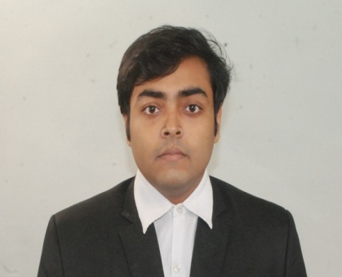
SAIKAT BAGCHI

Career Objective:

I want to be a complete professional with exposure to analytical and logical techniques though which an organization can be benefited.

Profile Summary:

I am an enthusiastic and committed teacher with a natural ability to appreciate and inspire students. Effectively deal with students with learning problems. I can remarkably interpret a variety of instructions furnished in written, oral, diagram, or schedule form. I am such kind of person who is promising to satisfy educational needs of the students.

Education
Year | Institute |  | Degree | Specialization | Marks/Grade
2010-2014 | RCCIIT |  | BTECH  (WBUT) | ELECTRONICS AND COMMUNICATION | 78.9%
2009 | SODEPUR HIGH SCHOOL |  | WBCHSE | SCIENCE | 81.6%
2007 | SODEPUR HIGH SCHOOL |  | WBBSE | GENERAL | 89.25%

Computer Proficiency:

- MATLAB
- SPSS
- MS OFFICE

Language known:

- ENGLISH
- HINDI
- BENGALI

Professional Experience:

Experience
Year | Institute |  | Faculty position
2017-2019 | Transition career solution |  | Math and physics faculty for  NEET, IITJEE mains and advance
2016-2017 | Dreamz Barasat |  | Math faculty for WBJEE ,  11and 12 boards, IITJEE
2015-2016 | Emerald Guidance Educational |  | Math faculty for boards and  IITJEE

Specialization for IITJEE subjects:
- Math
- Physics

Achievements:
- Crack gate several times with the best rank of 27 in the year 2017
- Best faculty in Transition career solution in the year 2018-19
- Certification from Bsnl .
- In my professional career, almost 25 students got over 90% in IITJEE mains.

Personal Detail

Date of Birth - 12th December, 1990

Home Town - Kolkata

Address - Jananagari, Rupayan-1, C.K.SEN road
, Agarpara, kolkata-700109

Contact Number - 9836351322, 8961690515

SAIKAT BAGCHI DATE

