RESUME

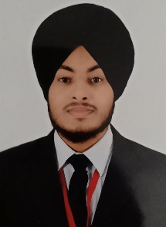
Simranjit Singh
ADDRESS

V.P.O Loharan, Jalandhar
Mobile No.:8872980693
Email Id :simran123506@gmail.com

OBJECTIVE
- Seeking a challenging position in a reputed organization where I can learn new skills, expand my knowledge, and leverage my learnings.
ACADEMIC QUALIFICATIONS
Course | Name of the Institution | Board/University | Year of Passing | Marks scored
B.T.T.M | Innocent Hearts Groups of Institutions | Punjab Technical University
12(non med)  10th | Govt. Sen sec school khambra  Govt. Sen. Sec. School lambra | PSEB  PSEB | 2018  2016 | 64%  76%

VOCATIONAL TRAINING

- Online course:- Introduction to tourism industry management (2weeks)
- Online course :- Basics of Lightroom (1week)

STRENGTHS

- Hard Working and Honesty
- Situation handler.
- Punctual and polite.
- Good listener
HOBBIES

- Photography
- Volleyball
- Gaming
PERSONAL PROFILE
- Father's Name : Parminder Singh
- Gender: Male
- Marital Status: single
- Nationality: Indian
- Languages Known: Hindi, English,Punabi
- Address :V.P.O Loharan, Jalandhar

DECLARATION

I hereby declare that the particulars are true & complete to best of my knowledge and belief wishing for your earlier and positive response in this direction.

Simranjit Singh

