CURRICULUM-VITAE

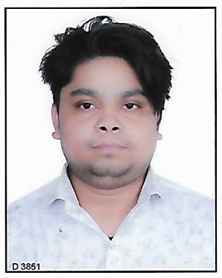
Vipin kumar
Address: house no-F-09 Street no-6 Phase-1
Bhagirathi vihar delhi-110094
Mobile: 9650073076
Email:vk94019@gmail.com

To acquire professional experience and contribute to growth of the organization through commitment for the quality and hard work.

ACADEMIC QUALIFICATIONS

- 10th pass from CBSE.
- 12th pass from NIOS.
- BA programme Completed from sol Delhi University.
- MA political science pursuing from Ignou.

TECHNICAL QUALIFICATION

- Three year diploma course in garment fabrication technology from Aryabhata institute of technology (Board of Technical Education) delhi110033.
- Certificate in tuka tech from apparel training and design centre Dilshad garden.
- Pursuing BE textile engineering from The Institution of Engineers (IEI Kolkata University).
- Course on Computer Concepts

TRAINING AND INTERNSHIP

- One month industrial training in AS fashion private limited (one month training from 01.06.2015 TO 30.06.2015).

HOBBIES & INTEREST

- Internet surfing.
- chess

LANGUGAE KNOWN

- English, Hindi

PERSONAL DETAILS

Father Name : Pooran singh
Date of Birth : July 2nd 1993
Gender : male
Nationality : Indian
Strength : Hardworking and Confident

Declaration: I hereby declare that the above mentioned information is correct up to my knowledge and i bear the responsibility for the correctness of the above mentioned particulars.

Date: …………………………… (Vipin Kumar)

